**Lab Exercise 5– Terraform Variables with Command**

Line Arguments

Objective: Learn how to pass values to Terraform variables using command line arguments.

Create Terraform Configuration Files:

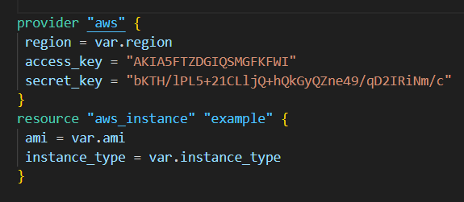

Create a file named variables.tf:

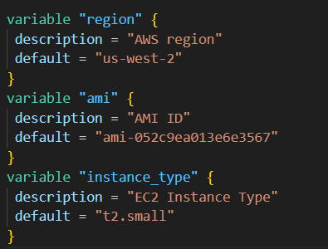

. Use Command Line Arguments:

• Open a terminal and navigate to your Terraform project directory.

• Run the terraform init command:

Terraform apply

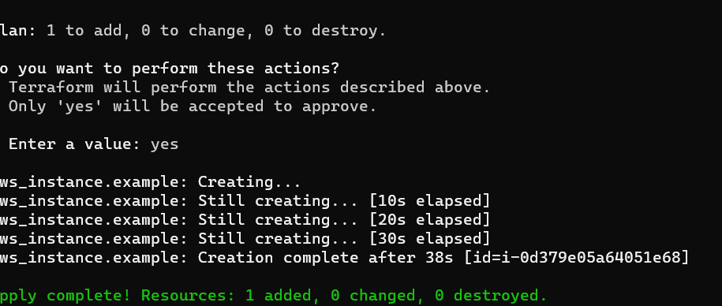

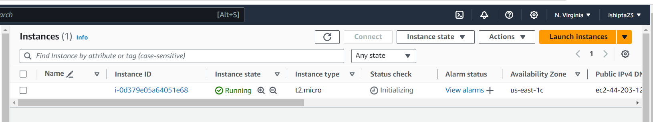

Clean up

Terraform destroy

